CHANGES HISTORY
PIC | Date | Remarks
BJM.MR | 2018.05.04 | Created
Ghaida | 2018.05.04

TOC
- Parameter Afa Transaction Trx Link
- Parameter Afa Transaction Trx type

Diagram ENTITY RELATIONSHIP

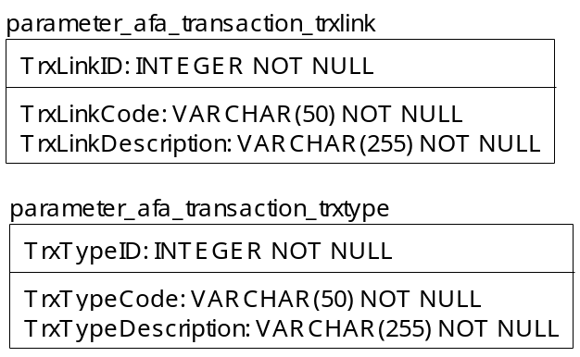

TABLE RELATIONSHIP
No | Table 1 | Table 2 | Type (1:1; 1:N; M:N) | Description

Name |  | parameter_afa_transaction_trxlink
Objective
No | Column |  | Type | Rule  (PK, FK, Key, NN, Unik, Index) | Description
1. | TrxLinkID |  | Integer | NN
2. | TrxLinkCode |  | Varchar(50) | NN
3. | TrxLinkDescription |  | Varchar(255) | NN

SAMPLE DATA
No | Column | Sample 1 | Sample 2 | Sample 3 | Sample 4
1. | TrxLinkID | 0 | 1 | 3 | 4
2. | TrxLinkCode | TD BREAK REVERSAL | BANK TRANSFER IN | BANK TRANSFER OUT | BANK TRANSFER OUT REVERSAL
3. | TrxLinkDescription

Name |  | parameter_afa_transaction_trxtype
Objective
No | Column |  | Type | Rule  (PK, FK, Key, NN, Unik, Index) | Description
1. | TrxTypeID |  | Integer | NN
2. | TrxTypeCode |  | Varchar(50) | NN
3. | TrxTypeDescription |  | Varchar(255) | NN

SAMPLE DATA
No | Column | Sample 1 | Sample 2 | Sample 3 | Sample 4
1. | TrxTypeID | 1 | 2 | 3 | 4
2. | TrxTypeCode | EQ BUY | EQ SELL | FI BUY | FI SELL
3. | TrxTypeDescription | Equities Purchase | Equities Sale | Fixed Income Purchase | Fixed Income Sale

